EXERCISE 2B-QUINTA KHATORO

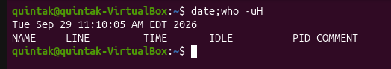
It displays the current day, date, time and year plus a header.
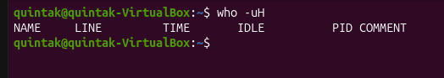
Just the header is displayed.

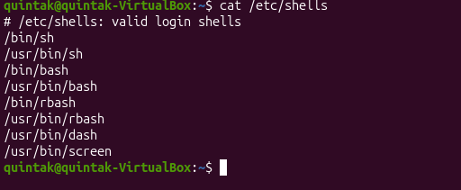
A list of valid login shells
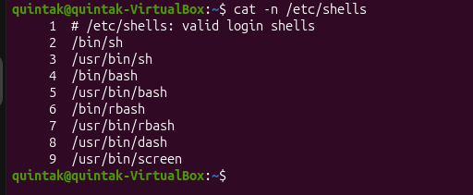
The same list just numbered this time
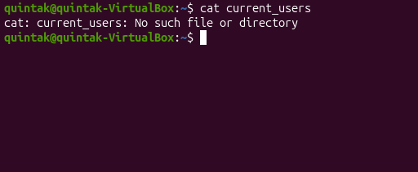
There is no such file.

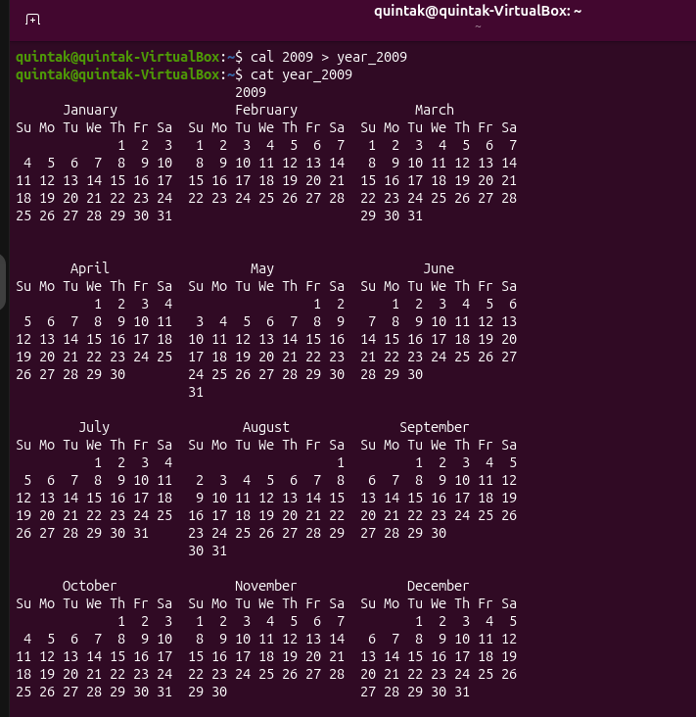
3.


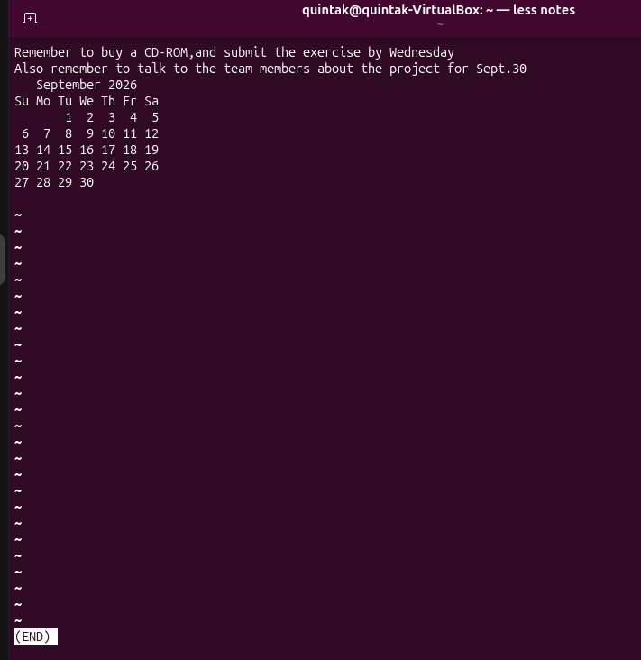
4.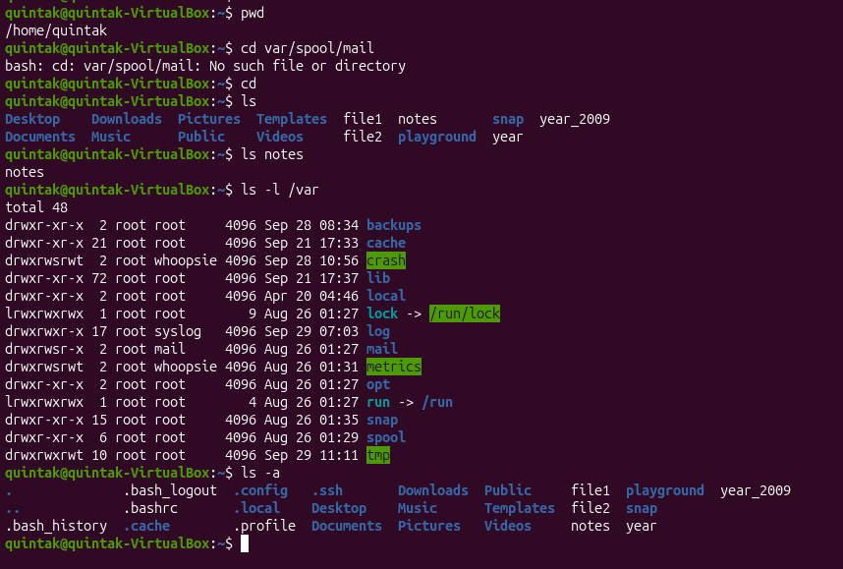
Current path: /home/quintak.
Output: No such file/directory.
cd + Enter returns me back to my home directory.
ls shows all the files I have.
ls notes confirms the notes file exists .
ls -l /var lists the content in the directory.
ls -a displays all files and directories including hidden ones.

5.
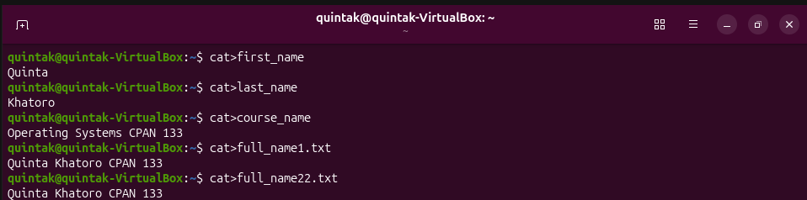



ls *name shows the first three files I created
ls full_name?.txt displays only full_name1.txt
ls *.txt displays full_name1.txt and full_name22.txt

6.
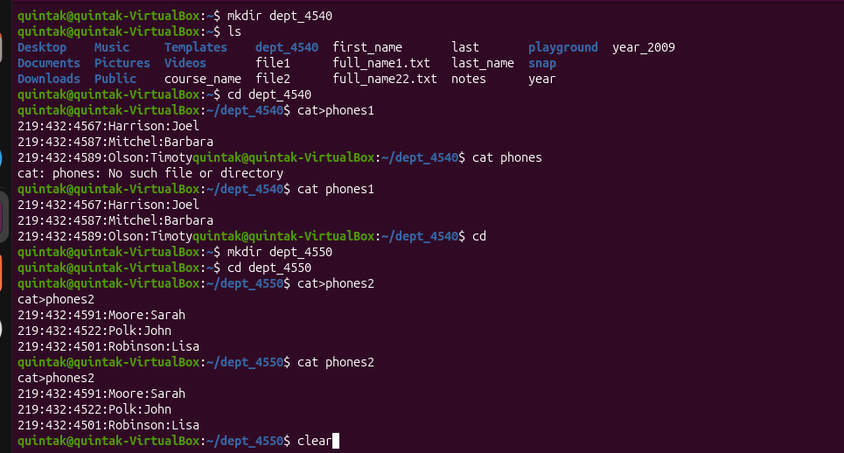
mkdir dept_4540 =no output but it creates a directory.
ls shows the new folder that has been created in my files .

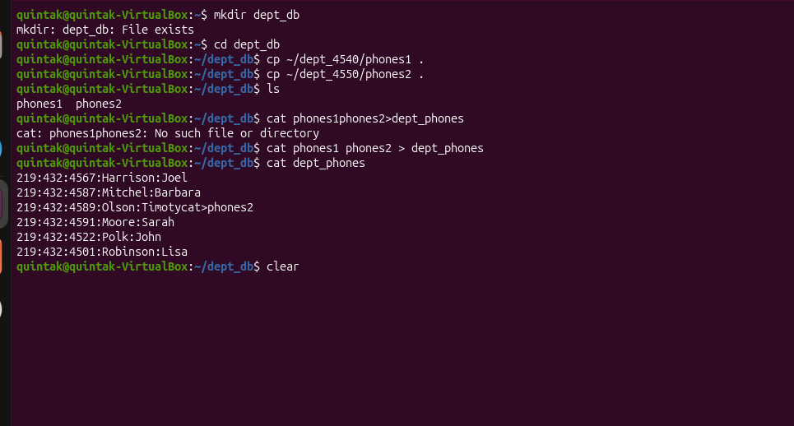
7.

mkdir dept_db shows File exists.
cat phones 1 phones2 > dept_phones does not display anything but a new file that combines both is created.

